LAB 04 SHRIHARI VISWANATHAN 1BF24CS288 BANK ACCOUNT DB PART 2;

Find all customers who have an account at all the branches located in a specific city ex: Delhi

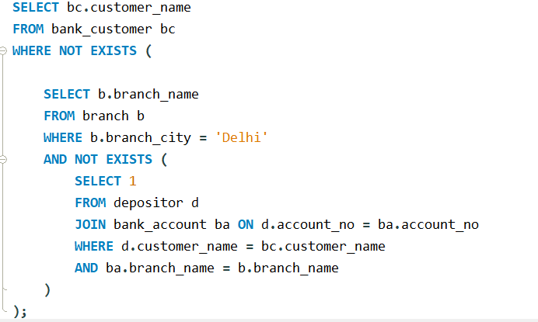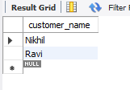

Find all customers who have a loan at the bank but do not have an account.

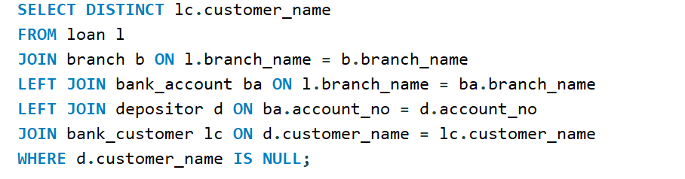

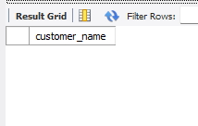

Find all customers who have both an account and a loan at the Bangalore branch

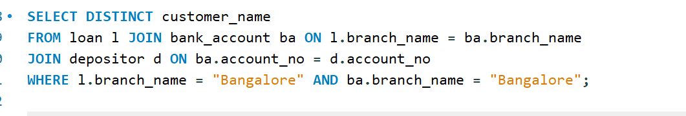

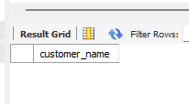

Find the names of all the branches that have greater assets than all the branches located in Delhi

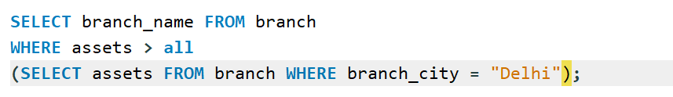

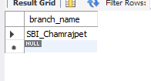

Demonstrate how you delete all the account tuples at every branch located in a specific city ex: Delhi

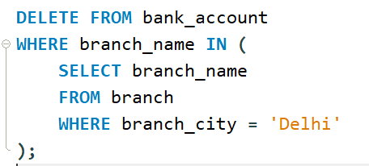

Update the annual interest payments are made and all branches are to be increased by 5%

